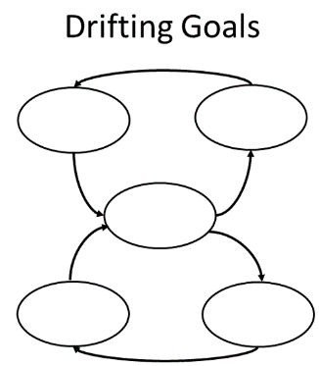

**Alt text:**

Generic diagram of Drifting Goals archetype; ovals—one at center, two above, two below—represent variables linked by arrows.

**Long description:**

Vertically oriented causal loop diagram with empty central oval flanked by two more ovals above it and two more, below it. Arrows point to and from the ovals, intended to be adjusted when generic causal loop diagram is filled in with specific information.

**Alt text:**

Generic diagram of Escalation archetype; seven ovals representing variables form two loops linked by arrows.

**Long description:**

Horizontally oriented causal loop diagram with empty central oval and six more ovals, three linked to each side of the central oval. Arrows point to and from the ovals, intended to be adjusted when generic causal loop diagram is filled in with specific information.

**TASK TWO DIAGRAMS**

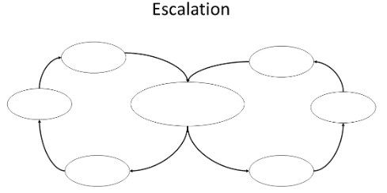  
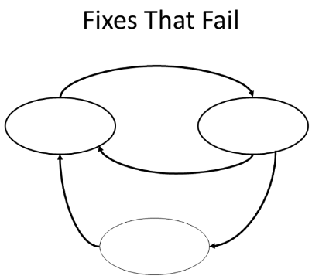

**Alt text:**

Generic diagram of Fixes That Fail archetype; ovals—two side-by-side and another below— represent variables linked by arrows.

**Long description:**

Causal loop diagram with two empty central ovals side-by-side and a third below them and centered. Arrows point to and from the ovals, intended to be adjusted when generic causal loop diagram is filled in with specific information.

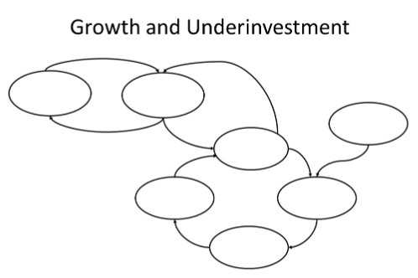

**Alt text:**

Generic diagram of Growth and Underinvestment archetype; a number of ovals represent variables are linked by arrows.

**Long description:**

Causal loop diagram with seven empty ovals forming several loops. Arrows point to and from the ovals, intended to be adjusted when generic causal loop diagram is filled in with specific information.

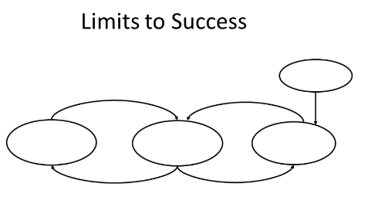

**Alt text:**

Generic diagram of Limits to Success archetype; four ovals representing variables form two loops linked by arrows.

**Long description:**

Causal loop diagram with three empty ovals form two loops. A fourth oval is positioned above and to the right of the main diagram. Arrows point to and from the ovals, intended to be adjusted when generic causal loop diagram is filled in with specific information.

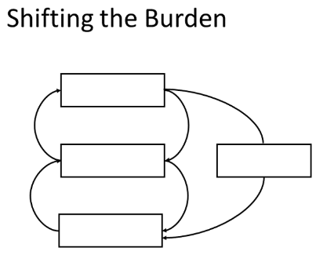

**Alt text:**

Generic diagram of Shifting the Burden archetype; four rectangles representing variables form loops linked by arrows.

**Long description:**

Causal loop diagram with three empty rectangles form two loops. A fourth rectangle is positioned to the right of the main diagram. Arrows point to and from the ovals, intended to be adjusted when generic causal loop diagram is filled in with specific information.

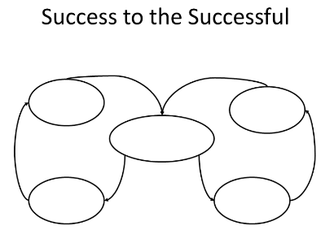

**Alt text:**

Generic diagram of Success to the Successful archetype; five ovals representing variables form loops linked by arrows.

**Long description:**

Causal loop diagram with five empty ovals forming two loops. The central oval is linked to two separate loops on left and right. Arrows point to and from the ovals, intended to be adjusted when generic causal loop diagram is filled in with specific information.

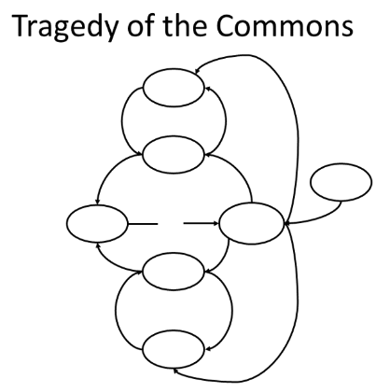

**Alt text:**

Generic diagram of Tragedy of the Commons archetype; seven ovals representing variables form multiple loops linked by arrows.

**Long description:**

Causal loop diagram with seven empty ovals forming five loops, some inside others. A single oval is positioned outside the loops to the right. Arrows point to and from the ovals, intended to be adjusted when generic causal loop diagram is filled in with specific information.